PRACTICAL 6: LAN CONSTRUCTION AND SWITCH CONFIGURATION
Objective
Build a LAN using a Cisco Catalyst switch.
Equipment
- 10 PCs
- Cisco Catalyst 3560 Switch
- Patch Panel
- Fly Leads

Activities
- Connect all 10 PCs.
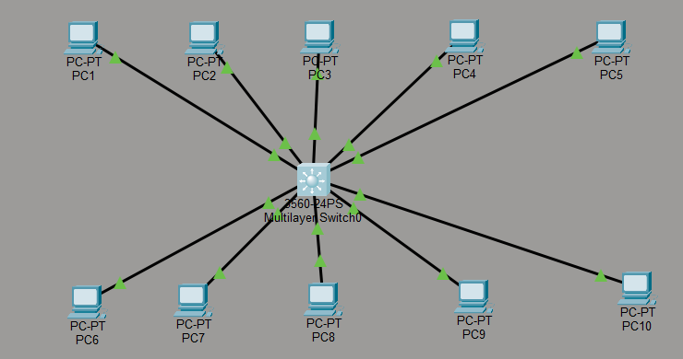
Figure 1: 10 pc's connected
- Configure static IP addresses.
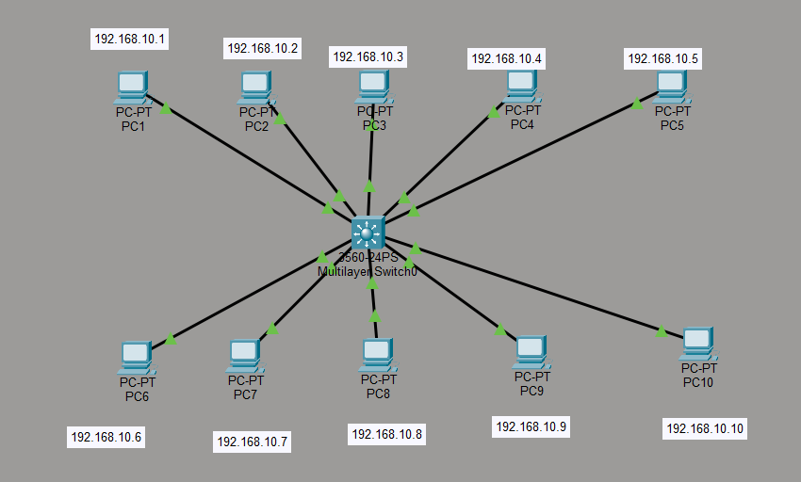
Figure 2: Static IP adressess configured
- Configure switch management interface.
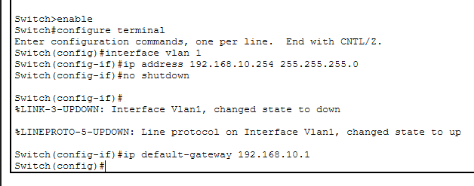
Figure 3: Switch config
- Verify connectivity.
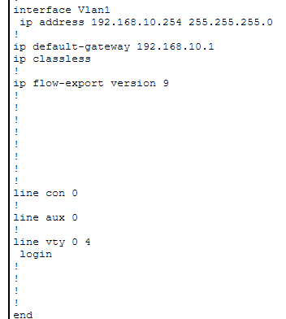
Figure 4: show running-config on switch
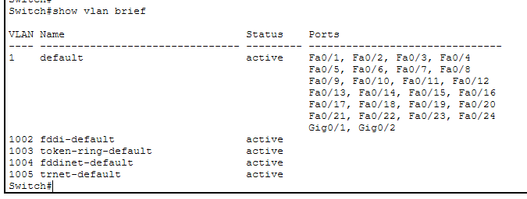
Figure 5: Show vlan brief on switch
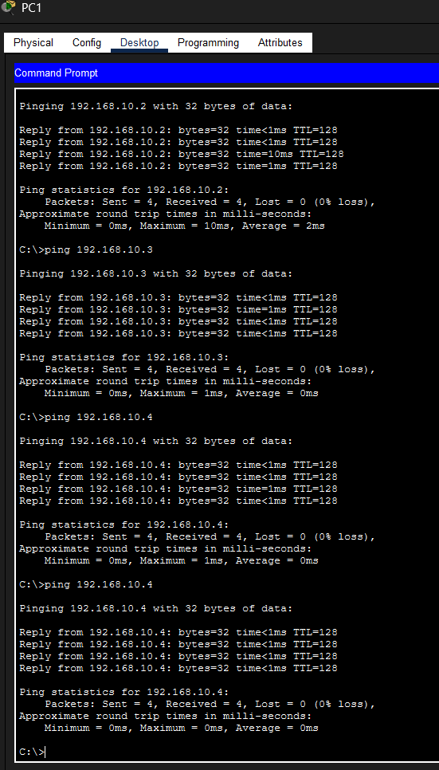
Figure 6: ping from PC1 to PC2-4
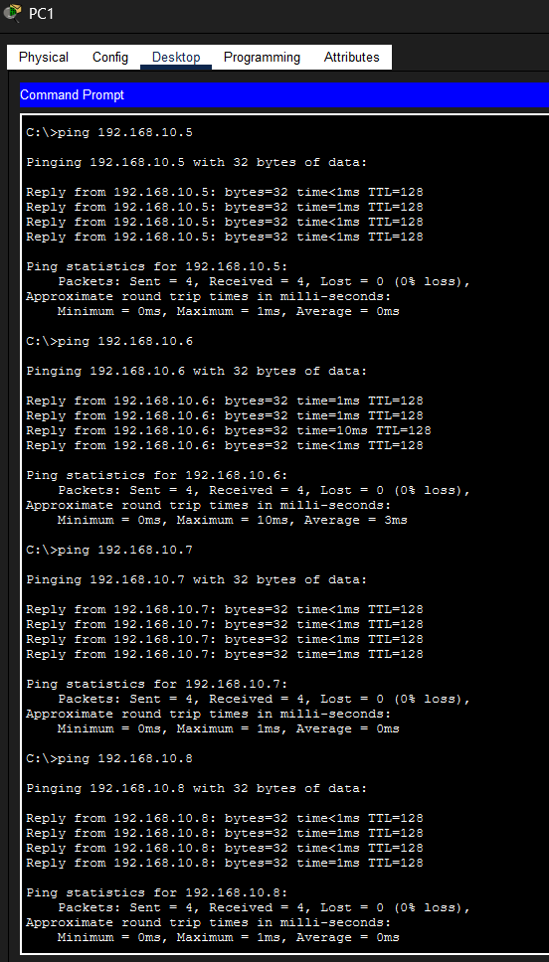
Figure 7: ping from PC1 to PC5-8
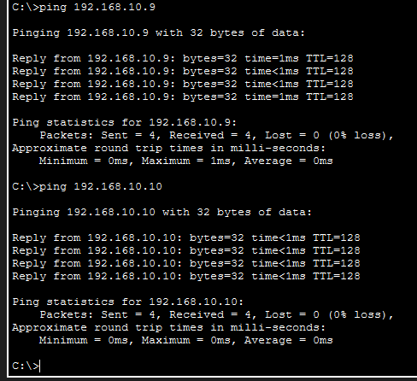
Figure 8: ping from PC1 to PC9-10
- Create a network diagram.

IP Addressing Scheme Device | IP Address
PC1 | 192.168.10.1
PC2 | 192.168.10.2
PC3 | 192.168.10.3
PC4 | 192.168.10.4
PC5 | 192.168.10.5
PC6 | 192.168.10.6
PC7 | 192.168.10.7
PC8 | 192.168.10.8
PC9 | 192.168.10.9
PC10 | 192.168.10.10
Switch VLAN 1 | 192.168.10.254

